UNIT TESTCASES:

Testing API with Mocha:

Testcases:

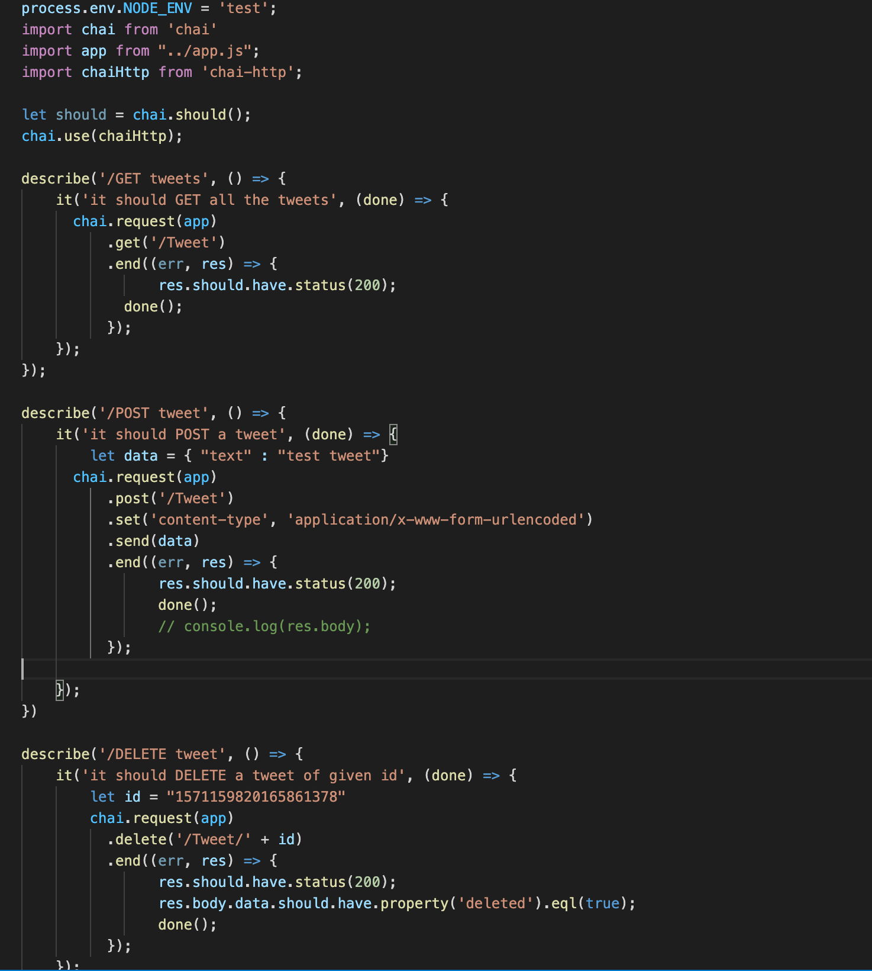

To test data when tweet is called by Get & post API:

Status:Passed.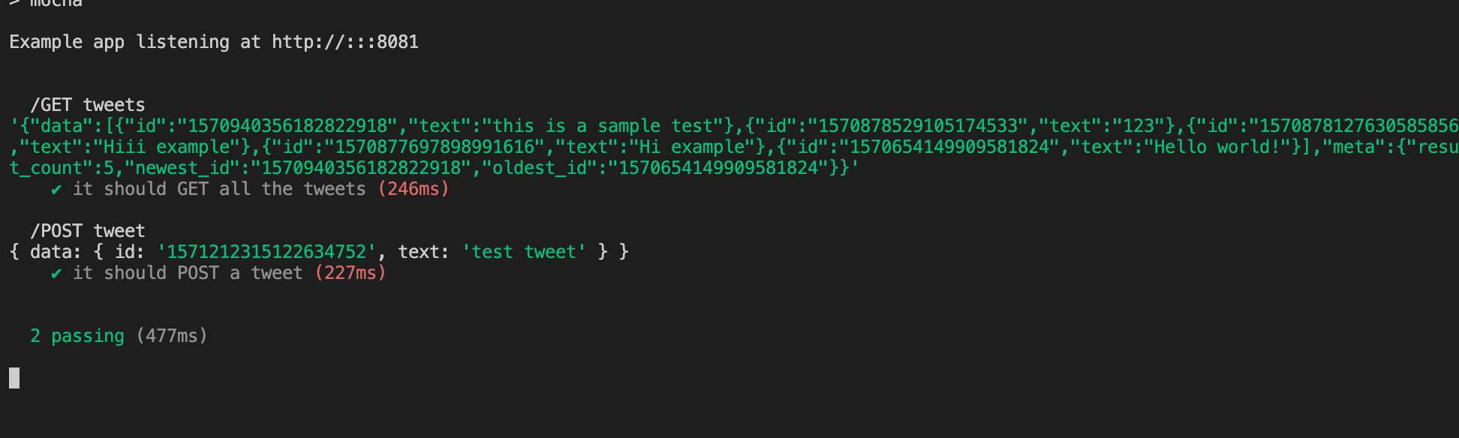

To test code when tweet is deleted:

Status:passed

